**Find the lamp in the following picture.**

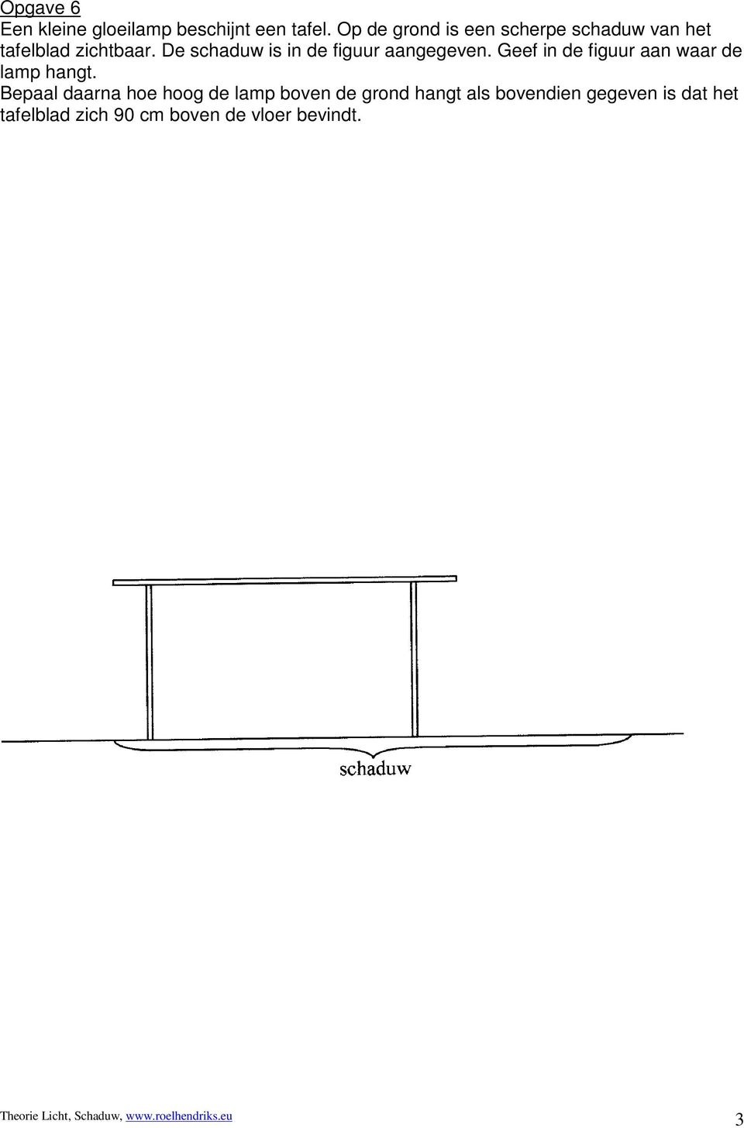

* figuur 2

Draw the shadows off the lanterns, write down U for umbra and P for penumbra

